AIR RESERVATION SYSTEM
Major project report
Submitted by
FAIZAN AHMAD
Enrollment No. ( 2015-301-021 )
In partial fulfillment for the award of the degree of
BACHELOR OF COMPUTER APPLICATIONS
Under the supervision of
MR.NAFISUL RAHMAN


Department of Computer Science & Engineering School
Jamia Hamdard, Hamdard Nagar New Delhi – 110062
2019

DECLARATION

I, FAIZAN AHMAD a student of Bachelor of Computer Application (BCA), Enrollment no: 2015-301-021 hereby declare that the entitled “ AIR RESERVATION SYSTEM ” which is being submitted by me to the Department of Computer Science, Jamia Hamdard, New Delhi in partial fulfillment of the requirement for the award of the degree of Bachelor of Computer Application (BCA), is my original work and has not been submitted anywhere else for the award of any Degree, Diploma, Associate ship, Fellowship or other similar title or recognition.

Date: 18/4/2019

Place: DELHI
Acknowledgements
I would like to thank all the people who have helped me in the completion of this project. First of all I would like to thank my project supervisor NAFISUL RAHMAN for his helpful guidance in the completion of this project. I would like to take this opportunity to thank all the people who have helped me in collection of information, removing of errors and making of the report.
I am highly grateful to all the people for helping me by providing their precious time, utilizing their energy and helping me with their wisdom.

THANK YOU

FAIZAN AHMAD
BCA ( VIth Sem )

CONTENTS TABLE

CHAPTER – 1 INTRODUCTION 1-11
- About Project 1
- Objective of the project 2
- Purpose of the project 3
- Project overview 4
- What is reservation system 5
- OOPs 6
- Problem Selection 10
- Existing System 11

CHAPTER – 2 DEVELOPMENT PROCESS MODEL 12-25
- Object Oriented Development 17
- System Analysis 18
- Problem current system 19
- Software And Hardware Requirement 20
- Data Flow Diagrams 21
- E-R Diagram 23
- Program Structure 25
CHAPTER – 3 SCREENSHOTS 26-34
CHAPTER -4 Scope of the Project 35
CHAPTER – 5 CONCLUSIONS 36
CHAPTER – 6 BIBLIOGRAPHY 37

CHAPTER – 1
INTRODUCTION
INTRODUCTION

This project on Airline Management System is the automation of registration process of airline system. The system is able to provide much information like passenger’s information, criminal’s, list of all passengers etc. The system also allows us to add records when a passenger reserves a ticket. For data storage and retrieval we use the file-handling facility of C Language. It enables us to add any number of records in our database. But for intrinsic nature of file handling, the retrieval process is slow when we Search a particular record in the database, because record is searched sequentially.

About Project
The project named “Airline Management System” is written in Turbo C++ IDE3.0, mainly because of its suitability for this type of application. Its user friendly nature and in-built documentation, complication, error detection, binding facilities and interaction with other software packages make it most powerful tool for software development. Moreover .Turbo C++ consists of all the technologies that help in creating and running robust, scalable and distributed packages.C++ is a general-purpose object-oriented programming language, and is intended to be an improved C with object capabilities Assistance is provided to the user at each and every step so that no problem is faced during using it. Further the details of every process and the user manuals attached in the report make it very easy to understand. Every possible care has been taken to make the software and the report clear, simple and error free which makes it so special and one of its kind.

Objectives of the Project
- .To provide some amount of automation in airlines mangement.
- .To help airlines system in making their business more efficient.
- . An added attraction for their potential customers.
- . It will also show the attitute of the management that they are aware to the newly
introduced technology and ready to adopt them.

Purpose of the project

Electronically handling of flight’s record to enhance the accuracy, flexibility,
Reliability and to remove the human’s error.
- An airline provides air transport services for passengers, generally with a recognized Operating
- To provide accurate information about the addition, deletion and modified movie’s Record.
- To provide, efficient, accurate, reliable, fast, and robust structure that can handle any Number of passenger’s transactions.

PROJECT OVERVIEW

  - Database and database systems have become an essential component of everyday life in modern society. In the course of a day, most of us encounter several activities that involve some interaction with the database. For example, if we go to the bank to Deposit or withdraw funds or if we make a Hotel or Airline Reservation, chances are that our activities will involve someone accessing a database.

  - The above interactions are examples of what we may call traditional database Applications, where most of the application that is stored and accessed is either textual or numeric. In our project we will concentrate on this aspect of computer application.

  - There are several ways to implement databases. Some of them are file handling Mechanism, relational database, object-relational database or object-oriented Databases. In our project we will use file-handling feature provided by C++ Language.

  - This program shows you an insight into the management process of reservation in Airline Management system. The whole process of Airline Management System is shown with the help of this project. It provides facility to add/Modify/ Delete /search Airline Management details. And provide facility to view the list of Team.

  - Facility to view the list of Team.

What is reservation system?
A project for automation of air reservation system. It facilitates the users with a graphical interface for enquiring and reservation. The system has been to be flexible to edit the database of train. The reservation can be done for the journey from any place regardless to the place of reservation. It generates a ticket or corresponding status message accordingly. The system must cater to all passenger services provided by AIR and must minimally provide support for reservation of different classes of seats, onward journeys tickets and cancel tickets. Providing support for reservation will also require that the system records information of the various airplane running on various routes as well as information about the routes themselves (including the airport and the timings of arrival and departure at/from each airport).

(OOPS – Object Oriented Programming System)

Object Oriented Programming is a method of programming that seeks to mimic the way we form models of the world. To cope with the complexities of life, we have evolved a wonderful capacity to generalize, classify and generate abstractions. Almost every noun in our vocabulary represents a class of objects sharing some set of attributes or behavioral traits.

The entire basis of Object Oriented Programming, infact is defining the Object in Object Oriented Programming. Object is a unit that combines both code and data together. And an object is an instance of a class. Class is a type of data structure defined to hold both data and the code functions.

Object Oriented Programming also allows you to design and implement your application more quickly than traditional approaches. Object Oriented Programming also makes code easier to maintain so that you can refine the implementation without causing major problems.

Organization of data and function in OOP

Some of the striking features of OOP:
- Emphasis is on data rather than procedure.

- Programs are divided into what are known as object.

- Data structures are designed such that they characterized the object.

- Functions that operate on the data of an object are tied together in the data structure.

- Data is hidden and cannot be accessed by external functions.

- Object may communicate with each other through function.

- New data and functions can be easily added where ever necessary.

- Follows bottom up approach in program design.

Basic Concepts of OOP:

1. Object:
Objects are the basic run-time entities in an object-oriented system. They may represent a person, a place, a bank account, a table of data or any item that the program has to handle.

2. Class:
The entire set of data and code of an object can be made a user defined data type with the help of class.

3. Encapsulation:
The wrapping up of data and function into a single unit is known as encapsulation.

4. Abstraction:
It refers to the act of representing essential features without including the background details or explanation

5. Inheritance:
It is the process of one class acquires the properties of object of another class.

6. Polymorphism:
It is another important OOP concept. Polymorphism a Greek term, means the ability to take more than one form.
. PROBLEM SELECTION

- Before making this application, we assumed that an airline which had recently started its operation found it very difficult to handle their customers.
- It was due to their great customer service and efficient handling of daily operations that they customer base started growing and in a day, they started to handle lot of customer requests. The problem is that in manual airline record keeping system, excessive staff employment is required, extremely time consuming process is involved, inconveniences to both customers as well as to the manager.
- Slowly & slowly the count of such customers started to grow very rapidly and the
- Airline employees had to devote their maximum time in handling such customers.
- Slowly, an airline started losing its important or gold customers due to poor response times by the employees and they even started losing those customers whose requests could not be fulfilled.
- After this, the management decided to install a system that can effectively &
Efficiently service the request of such customers and can the corresponding work of its employees who were overburdened with such tasks.
- This action was a step towards serving important or fresh customers with a minimum possible and improve the response times & efficiency of an airline employees.

- Objective of this software is to simplify the employee record using computers

Existing System:
The system is very time consuming and lazy. This system is more prone to errors and sometimes the approach to various problems is unstructured. If any old data or information is to be fetched then it is a great problem for user to get the information in short span of time as to get information from files is not an easy task. As everything is done manually, so if any record is misplaced then agency has to take full responsibility.

Limitation of existing system:
The earlier experiences have shown that manual monitoring of employee enquiries about their loans, conveyance, etc. Often fails to achieve the desired targets, mainly because of the following reasons:
- Much time required in giving correct information.
- Less reliability and maintainability of data.
- Secrecy of information may not be maintained due to visible facts on paper.
- Manual procedure of providing information is not reliable.

Every manager faces lot of minor & major problems like:
- Maintaining database.
- Record entry.
- Searching duplicate records.
- Searching & updating records.

An object oriented system draws upon class definitions that are derived from the analysis model. Some of the definitions will have to be built from scratch but many other can be reused if appropriate design patterns are recognized. Object oriented design establishes a design blueprint that enables a software engineer to the object oriented architecture in a manner that maximized reuse, thereby improving development speed and product quality.

CHAPTER – 2 DEVELOPMENT PROCESS MODEL

OJBECT ORIENTED DEVELOPMENT

An object-oriented system draws upon class definitions that are derived from the analysis model. Some of these definitions will have to be built from scratch, but many others may be reused it appropriate design patterns are recognized. Object Oriented Design establishes a design blueprint that enables a software engineer to define the Object Oriented architecture in a manner that maximized reuse, thereby improving development speed and end-product quality.

The four layers of object oriented design are:
- The Subsystem Layer: It represents each of the sub systems It represents each of the subsystems that enable the software to achieve its user-defined requirements and to implement the technical infrastructure.

- The Class and Object Layer: It contains the class hierarchies that enable the system to be created using generalizations and increasingly more targeted specializations.

- The Message Layer: It contains the design details that enable each object to communicate with its collaborators. This layer establishes internal and external interfaces for the software.

- The Responsibility Layer: It contains the data structure and algorithmic design for all attributes and operations for each object. Monitoring system activity and server performance is a necessary part of preventive maintenance for the server. Through monitoring, you obtain data that u can use to diagnose system problems, plan growth and trouble shoot problems. You can use the monitoring and status tool, diagnostic logging, extended logging and queue viewer to keep the data up-to-date.

Proposed System:

The proposed system is computer based, user friendly, and easy to maintain. It makes safely storing of records easy and for a very long period of time. It would significantly improve the quality of work in the airport. The time spent in processing the above mentioned queries would significantly reduce. The proposed system provides free, easy and efficient management of the day-to-day activities of the passenger’s in airline so that the manual work can be reduced and even minute details can be accessed easily

SYSTEM ANALYSIS AND STUDY
The system analysis is to be done to find initial details and requirement of the system.

EXISTING SYSTEM
In this stage of project development, study of the existing system is done. The outcome of this study helps in understanding the need for implementing a new system or even upgrading the existing one. Here, we study what are the difficulties that the normally faced. The fast access of information related to tickets, passengers were not possible.

PROBLEMS WITH THE CURRENT SYSTEM

The problem of current system is divided into sub problems
Manual system The system is very time consuming and lazy. This system is more pronto errors and sometimes the approach to various problems is unstructured.
Technical system with the advent of latest technology if we do not update our
System then our business result in losses gradually with time.
The technical systems contains the tools of latest trend i.e.
Computers printers, fax, Internet etc. The systems with this
Technology are very fast, accurate, user-friendly and reliable.

TOOLS & PLATFORM USED

- Technical Feasibility
- This Hardware requirement is moderate (Pentium 400 MHz with 64 MB RAM Minimum is needed) and software requirement wants C++.
- Produce output very quickly with quit good response time depending on PC’s speed.
- Can process a fair amount of data instantly depending on PC’s speed.

We have a wide range of options of languages. From these options we can choose appropriate platform/ tools and languages for development of the project. Some of these are as follows

Hardware Requirements:

Pentium - II to IV
Ram –32MB
H.D .space - 4xGB
FD
CD ROM DRIVE - 52x

Software Requirements:
Front-End Requirement Turboc C++
MS-Excel
MS-Word
Back-End Requirement File Handling

CHAPTER – 3

DATA FLOW DIAGRAMS

CONTEXT DIAGRAM OF AIR RESERVATION SYSTEM

AIR RESERVATION SYSTEM
Cancellation
Ticket
A lot Ticket

Ticket No

Reservation

Inquiry flight

Passenger

CONTEXT LEVEL DIAGRAM

DFD for Airline Reservation System

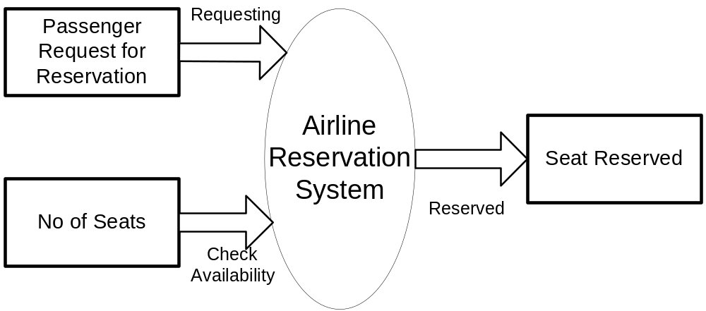
First Level of Data Flow Diagram for
General Inquiry System

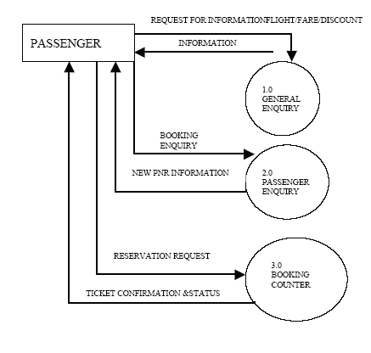

Second Level of DATA FLOW DIAGRAM
OF BOOKING SECTION

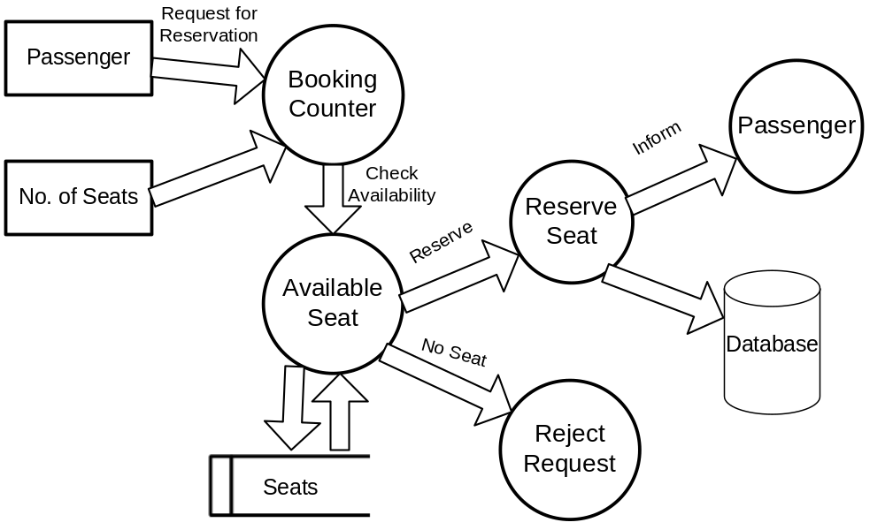

E-R Diagram

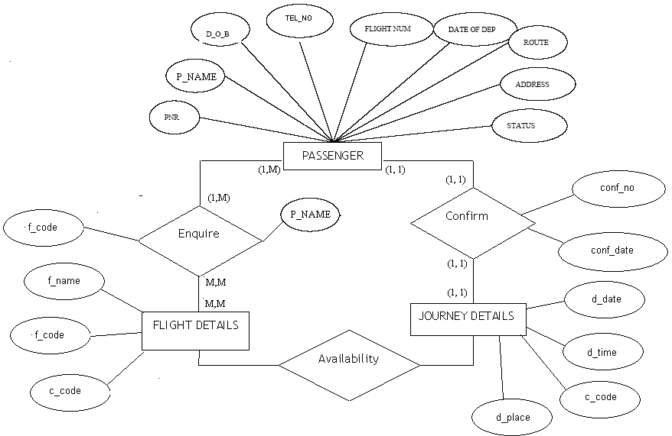

PROGRAM STRUCTURE

Reservation

Cancellation

Passenger Records
List of Passenger
Enquiry

Quit

CHAPTER – 4

SCREENSHOTS

SCREENSHOTS

Main Menu

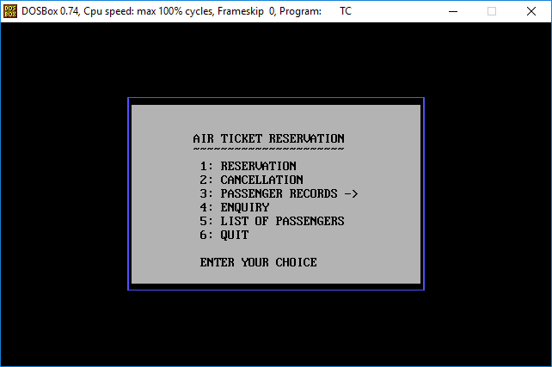

Cancellation

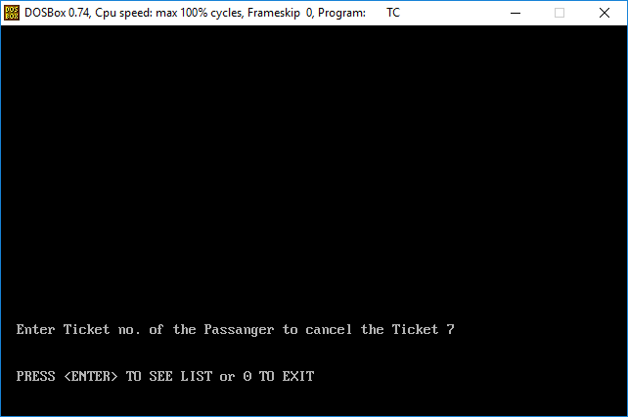

Cancel Ticket

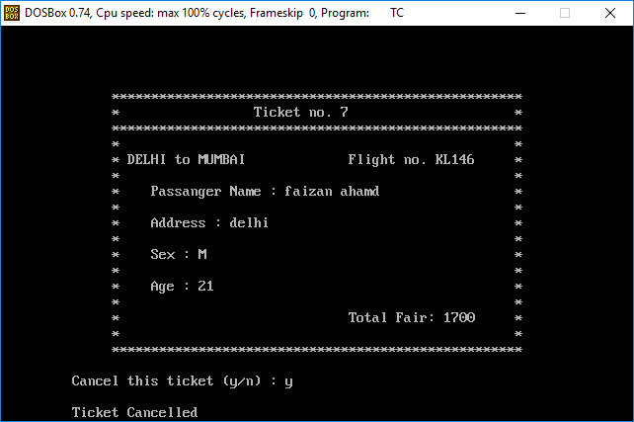

Reservation Steps

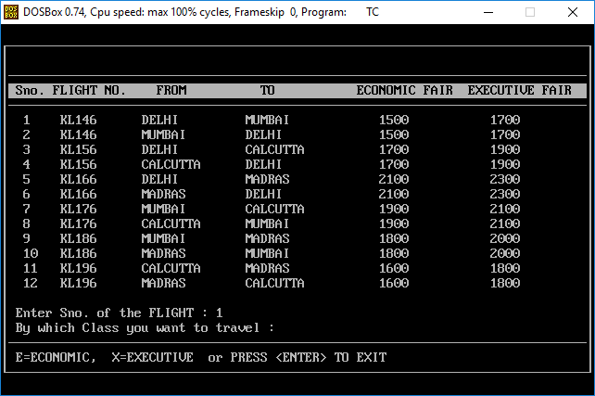

Reservation Ticket

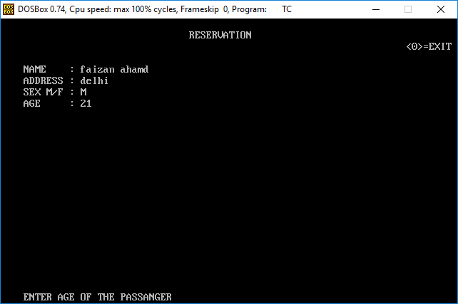

Ticket

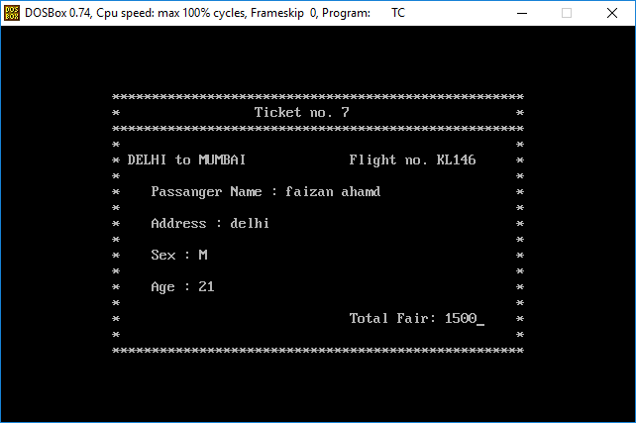

List of Passengers

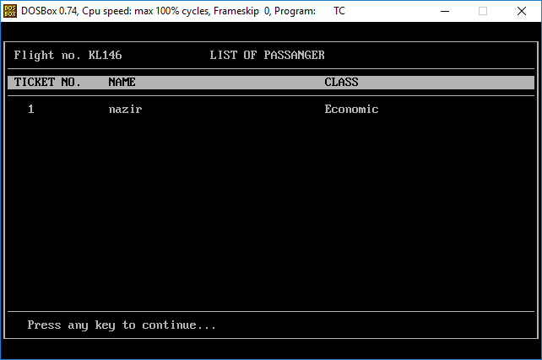

Passenger Information

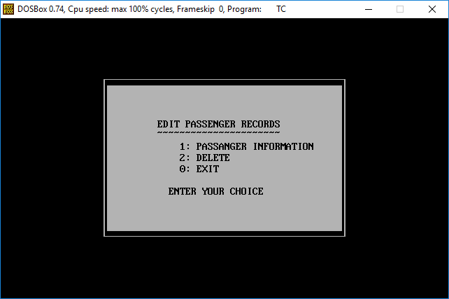

Passenger Records

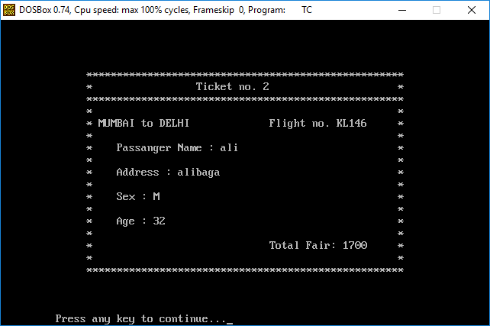

CHAPTER – 5

Scope of the Project

Scope of the Project

Scope of this project is to replace the manual work of movie shop mgmt. system with the new advanced computerized system. User does not need much training to use this software, as this software is very user friendly and easy to use. It replaces all the paper work also. In this software we can store thousands of records. It replaces all the calculation works also as it automatically calculate and print the bill. Some main advantages are:-

- Customer numbers are generated automatically by system itself.

- If any invalid entry done by the users which is nature of human being but checks by the machine so this software gives the error message to the users to indicate about the invalid entry.

- While transfer of any customer such as incoming customer, it will update both the file and incoming customer so that if we want to know number of incoming customer, it will be very easily for us.

CONCLUSION

We can hereby conclude that:
- The system effectively automated the functions involved in the processes being
Handled manually before.
- The cost & benefit analysis shows that the system was quite successful in saving costs For the bank & generate equivalently huge benefits
- The system is secure & scalable. The system design has been done keeping user-
Friendliness and efficiency in mind.

BIBLIOGRAPHY

- Programming in ANSI “C”-- E. Balagurusamy.

- OOP with “C++”-- E. Balagurusamy.

- Computer Graphics—Hearn D. and Baker P.M

. Teach yourself C by Yashwant Kanetkar, BPb Publishing house edition-6th.

. Software engineering, K.K. Aggrawal, new age international publisher.

